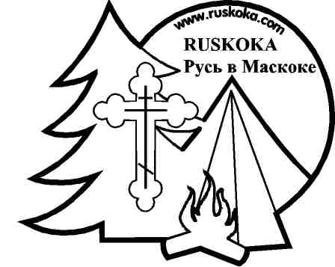
Ruskoka Camp
Camper Subsidy Program

Ruskoka offers a Subsidy Program that is intended to provide financial assistance to campers who would otherwise not be able to attend Ruskoka Camp due to lack of funds. Campers must permanently reside in Canada, and preferably in the Greater Toronto Area. Campers must be from 10 to 16 years of age.
This program can subsidize camper fees partially or completely, depending on the family financial circumstances. Applications for subsidies are reviewed on a case by case basis, and responses are provided within 2 weeks.
You may qualify for a camper subsidy (if some of the following apply):
- your annual family income is below $39,000
- your family is supported by social assistance (социальная поддержка) or welfare
- both parents (or single parent) are currently unemployed
- your family is living in subsidized housing
- your family is currently experiencing financial hardships
Please note that all subsidy application information and these forms will be kept strictly confidential, and destroyed after 1 year.
If you have any questions regarding the subsidy program or camp registration, please contact the Camp Director, Alik Sakuta (in Russian or English) at 416 232 0829 or by e-mail at alex@ruskoka.com
CONFIDENTIAL
Ruskoka Camper Subsidy Application Form 2021
Ruskoka Camp has established a Camper Subsidy Fund to assist families who may not otherwise be able to afford the full fees to send their children to summer camp at Ruskoka.
STEP 1. Complete a Summer Camp Registration form for each child.
STEP 2. Applicant Information
Parent/Guardian Information:
Name __________________________________ Signature _______________________________
Relationship _______________________________
Day Phone (_____)_________________
Cell Phone (_____)______________
Evening Phone (_____)_______________
Camper Information:

Camper #1: Name __________________________________________
Camper #2: Name __________________________________________
Camper #3: Name __________________________________________
Camper #4: Name __________________________________________
STEP 3. Financial information
- Please describe the reason for your subsidy request and why you are currently unable to pay the full camp fee.

Documents that show proof of income should be attached to this form, such as a photocopy of 2019 or 2020 Income Tax Return, photocopy of 2 current pay stubs from all employers, evidence of social assistance or welfare, etc. Documents sent as proof of income will be destroyed at year end.

- How much of the camp fees can you pay? $___________ per child (per session)

STEP 4. Other Information
Other Information:
- Have you applied to any other organization for a camp subsidy this summer? ___________ If yes, which organizations?

- Have you received a camper subsidy from Ruskoka Camp in the past? _________

- What other summer activities will your child(ren) participate in this summer?

- How will your child(ren) benefit from attending Ruskoka Camp this summer?

Send the completed camper subsidy application, proof of income documents and one complete registration form per child to:

Ruskoka Camp Registration
18 Fernalroy Blvd.
Toronto, ON M8Z 3V8

or by e-mail to alex@ruskoka.com

Note:
- Do not send any money at this time.
- Once your application has been reviewed, you will be contacted (usually within two weeks) regarding the amount of subsidy you are eligible to receive.
- Your child(ren) will not be guaranteed a spot in camp until your portion of fees has been paid.
- Please ensure that your application is complete and that proof of income documents and one camp registration form per child are attached
- Please check out our website (www.ruskoka.com) for further details regarding registration policies.
- As a condition of receiving a Ruskoka Camper Subsidy you may be contacted after the camp session has concluded to discuss how attending a session of summer camp has impacted your child(ren)
- Camper subsidies are provided on a first come, first served basis. Apply early!

